- Program ID : VP003MA1

- Display Layout
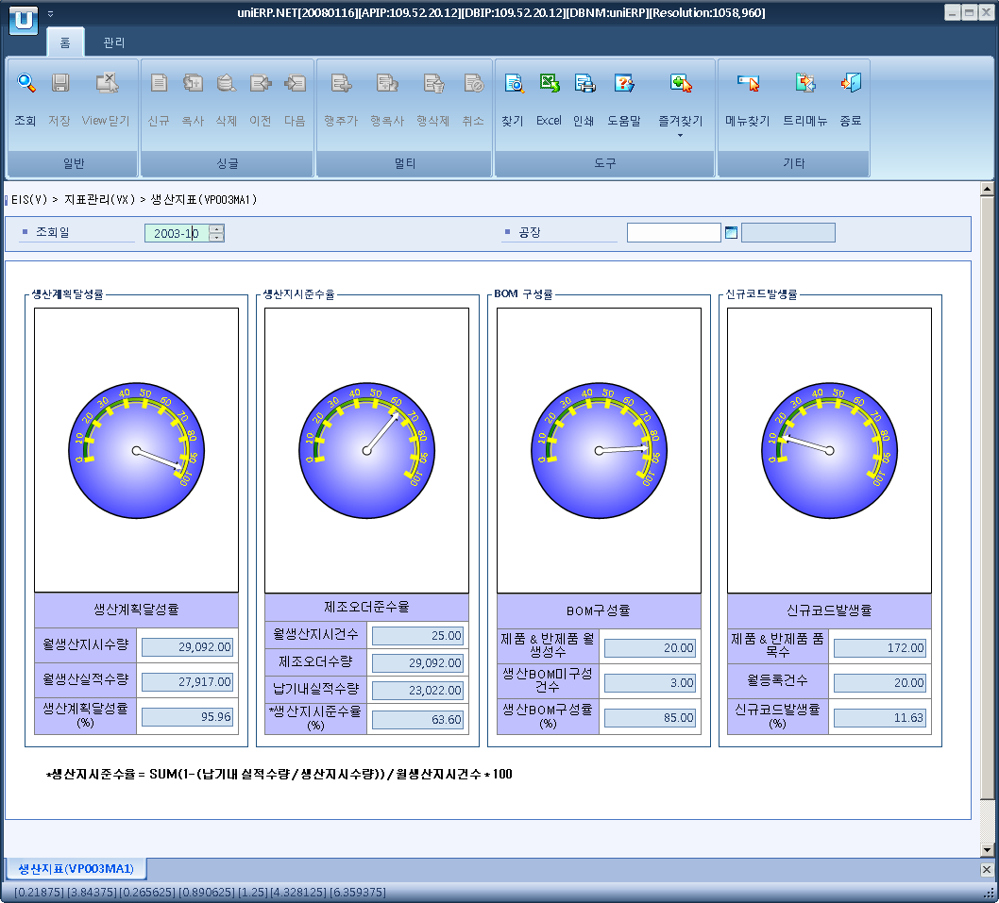

- Event flow
- Click Query button
- OnFncQuery -> DbQuery -> DataChange
- Display Unit combo change
- uniCombo1_ValueChanged -> DataChange

- SQL Statements
- Producton plan achievement rate
SELECT SUM(VP0030T.TOT_QTY), SUM(VP0030T.NOR_QTY), SUM(VP0030T.RATE)
FROM VP0030T
WHERE VP0030T.SP_ID = @strSpId
AND VP0030T.YYYYMM = @strYYYYMM
AND VP0030T.INDEX_CD = 'P01'

- Producton order achievement rate
SELECT SUM(VP0030T.TOT_QTY), SUM(VP0030T.NOR_QTY), SUM(VP0030T.TMP1_QTY), SUM(VP0030T.RATE)
FROM VP0030T
WHERE VP0030T.SP_ID = @strSpId
AND VP0030T.YYYYMM = @strYYYYMM
AND VP0030T.INDEX_CD = 'P02'

- BOM Composition rate
SELECT SUM(VP0030T.TOT_QTY), SUM(VP0030T.NOR_QTY), SUM(VP0030T.RATE)
FROM VP0030T
WHERE VP0030T.SP_ID = @strSpId
AND VP0030T.YYYYMM = @strYYYYMM
AND VP0030T.INDEX_CD = 'P03'

- New code rate
SELECT SUM(VP0030T.TOT_QTY), SUM(VP0030T.NOR_QTY), SUM(VP0030T.RATE)
FROM VP0030T
WHERE VP0030T.SP_ID = @strSpId
AND VP0030T.YYYYMM = @strYYYYMM
AND VP0030T.INDEX_CD = 'P04'

